**COAL LAB # 4**

**Ruhaan Ahmed**

**22k-6014**

**BSR 3A**

**Task 1:**

INCLUDE irvine32.inc

.data

arrayD DWORD 0007h , 0004h , 0001h , 0005h , 0002h

.code

main PROC

mov eax,0

mov eax,arrayD[8] ;COAL LAB 4 TASK 1

mov eax,arrayD[16]

mov eax,arrayD[4]

mov eax,arrayD[12]

call DumpRegs

mov eax,arrayD

exit

main ENDP

END main ; lab 1

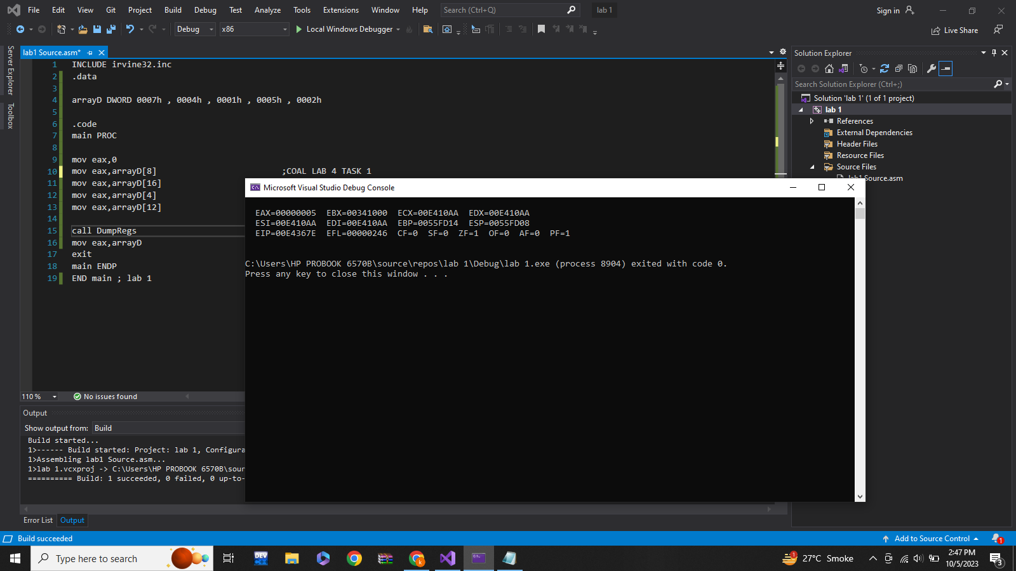

Task2:

INCLUDE irvine32.inc

.data

arrayB BYTE 10 , 20 , 30

arrayW WORD 150 , 250 , 350

arrayD DWORD 600 ,1200 , 1800

.code

main PROC

mov eax,0 ;COAL LAB 4 QUESTION 2

mov ebx,0

mov ecx,0

mov al,arrayB

add ax,arrayW

add eax,arrayD

mov bl,arrayB[1]

add bx,[arrayW+2]

add ebx,[arrayD+4]

mov cl,arrayB[2]

add cx,arrayW[4]

add ecx,[arrayD+8]

call DumpRegs

exit

main ENDP

END main

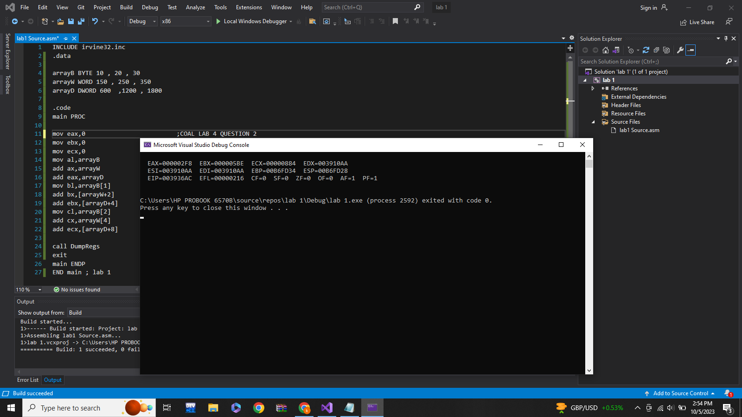

Task 3:

Include Irvine32.inc

.data

val1 dd 8000h

.code

main PROC

mov eax,val1

call Dumpregs

add eax,1000h

call Dumpregs

exit

main ENDP

END main

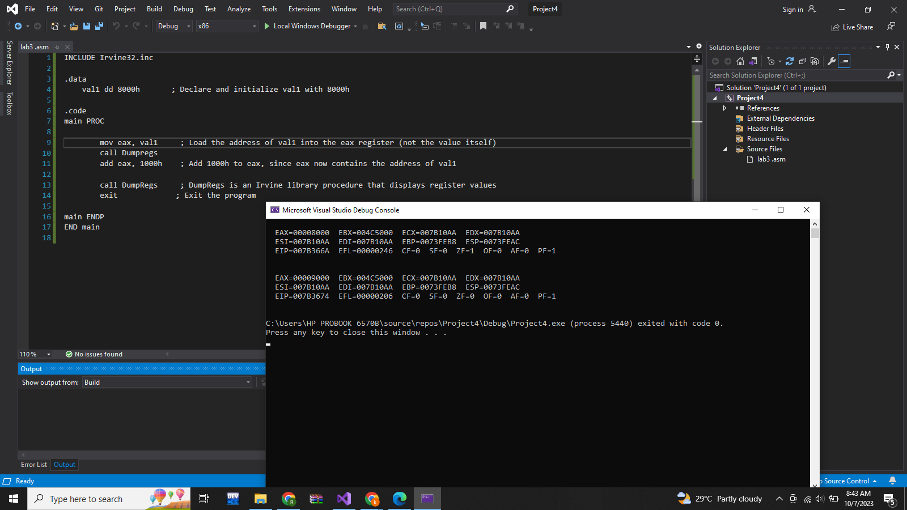

Task 4:

INCLUDE Irvine32.inc

.data

array1 BYTE 10 , 20 , 30 , 40

array2 BYTE 50 DUP(?)

.code

main PROC

mov eax,0

mov al,array1[3]

mov array2[0],al

mov al,array1[2]

mov array2[1],al

mov al,array1[1] ;coal lab 4 question 4

mov array2[2],al

mov al,array1[0]

mov array2[3],al

call DumpRegs

exit

main ENDP

END main

**Call dump regs so we can see flag register value for each asked execution**

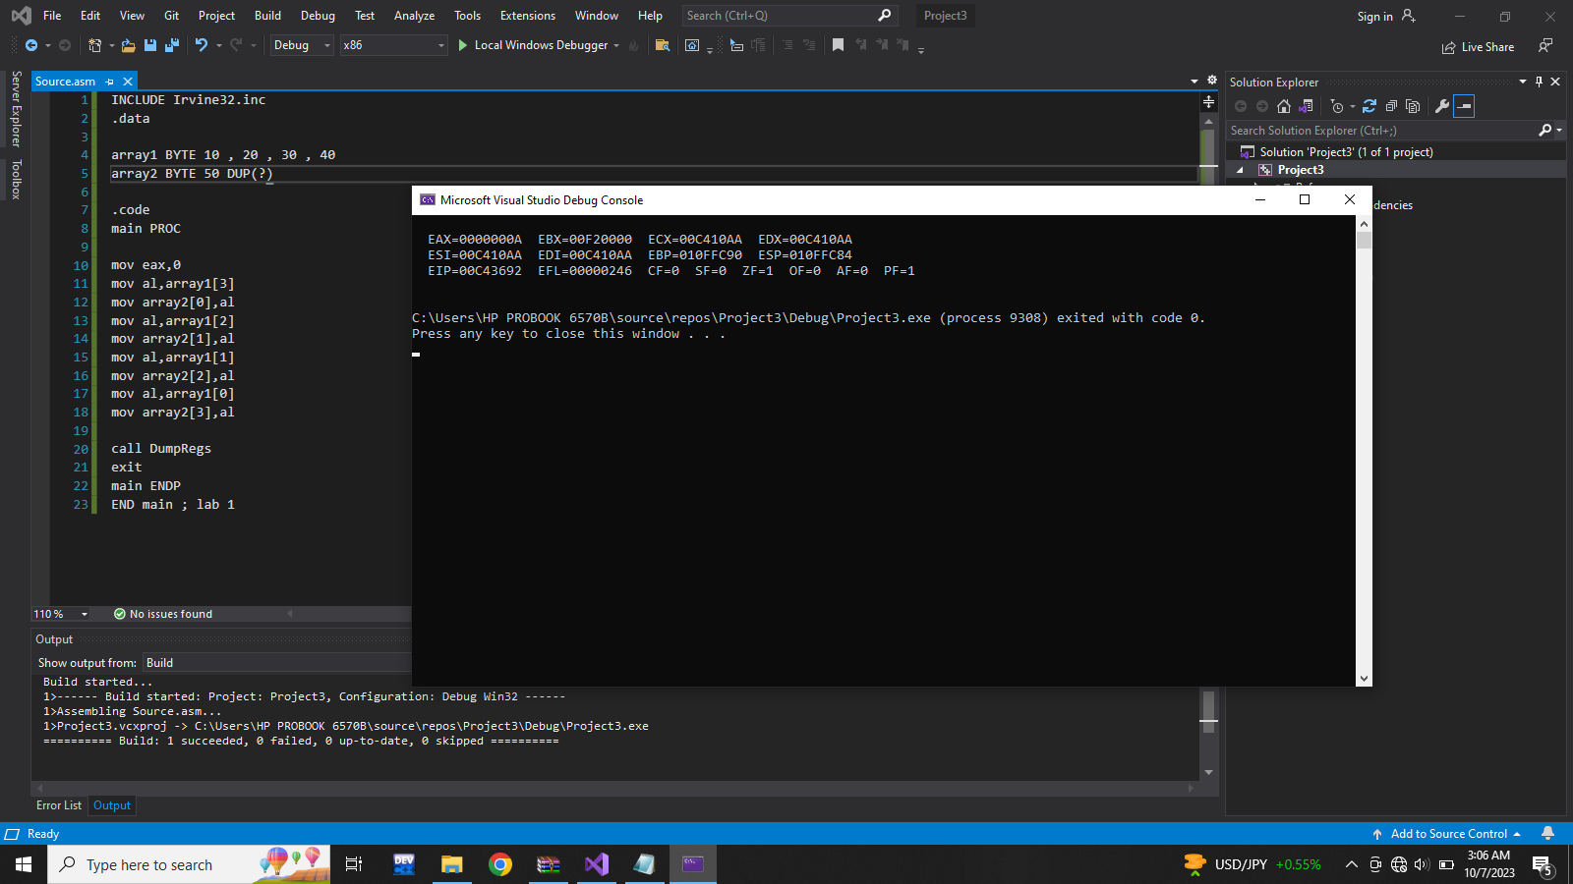

Task 5:

INCLUDE Irvine32.inc

.data

.code

main PROC

mov ax,7FF0h ;CF=?, SF=?, ZF=?, OF=?

call DumpRegs

add al,10h ;CF=?, SF=?, ZF=?, OF=?

call DumpRegs

add ah,1 ;CF=?, SF=?, ZF=?, OF=?

call DumpRegs

add ax,2

call DumpRegs

main ENDP

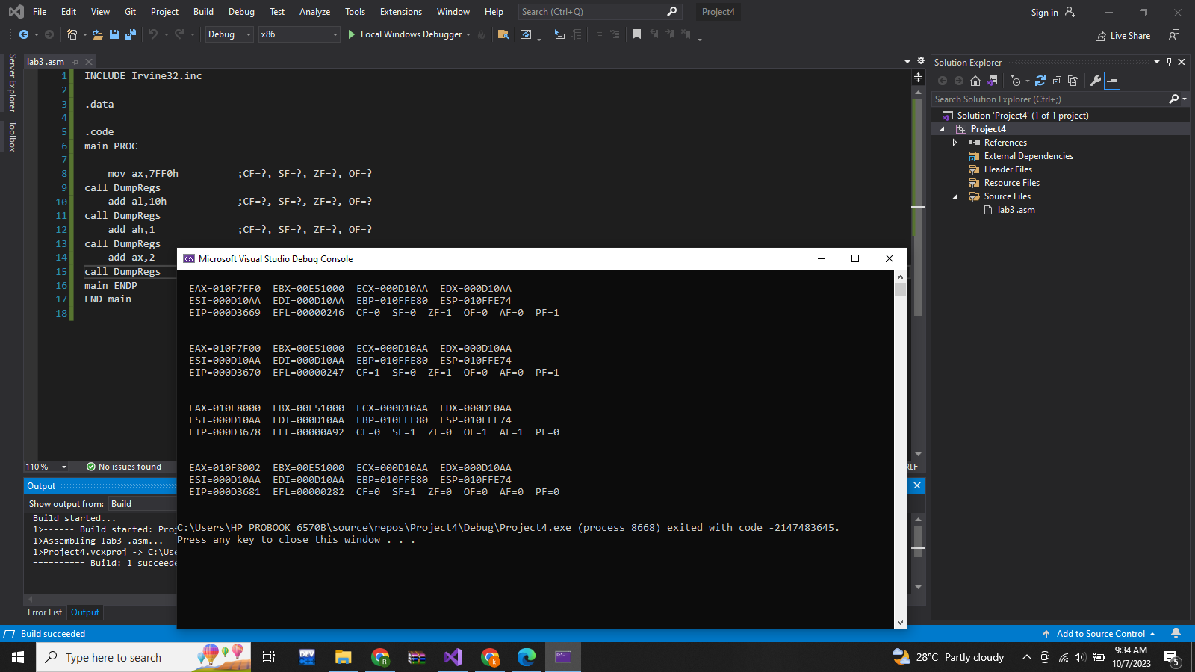

END main

**Call dump regs so we can see flag register value for each asked execution**